Douvres-la-Délivrande, France
Dover around the World by Lorraine Sencicle
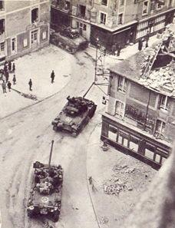
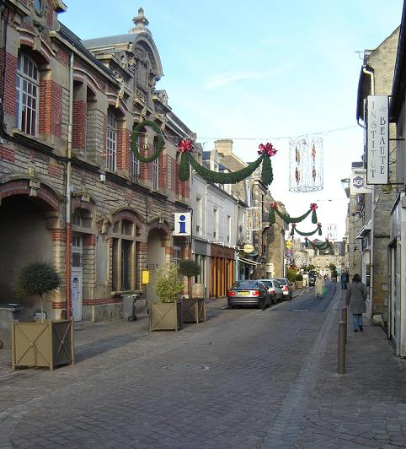
The origins of Douvres-la-Délivrande, north of Caen, Calvados, France, is lost in the mists of time. There was certainly an early Celtic settlement there and by 830 AD records show that there was a thriving village that was raided by Vikings. By the time of William the Conqueror, Osbern la Douvres and his wife, Muriel, held the Barony. The Manor house was built around 1072 and still stands although has been altered over time.
The Church, Notre Dame la Délivrande, which dominates the town, was rebuilt in 1150 following a disastrous fire. In the 19th century it subjected to a major rebuilding programme and re-consecrated in 1881. However, it was in 1664 that Gilles Buhot founded a pilgrim’s seminary in Délivrande, this was to be the basis of the town's future prosperity for as time passed and the number of religious houses increased to three. In 1869 the railway came to Douvres-la-Délivrande bringing yet more pilgrims and the towns prosperity was assured. The first half of the twentieth century saw number of new public buildings including the town hall, the court, schools, a stadium, public park and the famous baroque La Pharmacie Lesage.
However, all this came to an end with the outbreak of World War II. Douvres-la-Délivrande was occupied and as part of the Atlantic Wall defences, became the site of an important German air-detection radar installation. Now a museum, the heavily fortified radar station was completed in the autumn of 1943.The radar station was split by the road from Douvres-la-Délivrande to Béy-sur-Mer with the northern part holding a large Siemens ‘Wasserman’ long-range radar and associated structures. In the larger southern zone was two intermediate-range Freya and two short-range Würzburg Reise radars. The latter are considered to be the best-preserved examples in the world. At 23.00hrs on the night of 5/6th June 1944 the Allies launched intensive jamming of radar frequencies which blinded the entire German network from Cherbourg to Le Havre. The next morning scores of landing craft, part of a flotilla of almost 7,000 boats landed on the Normandy beaches. This was the start of the D-Day landings, code-named ‘Operation Overlord’ and the largest military operation in history. Most of the 135,000 Allied troops came ashore along 80km of beach north of Bayeaux each section had been given a code name. Sword, Juno and Gold Beaches, stretching from Ouistreham to Arromanches - some 35km - were attacked by the British 2nd Army with detachments of Canadians, Commonwealth, Free French and Polish forces.
The main British contingency landed at Sword beach and after fierce fighting moved inland. Their progress was slow and the casualties great, by 16.00hrs they were still five miles from Caen and a heavy German counterattack forced them to dig in. At Juno Beach, although mines had taken a heavy toll, the Canadians quickly headed inland. By midday they were south and east of Creulilly but the German armoured divisions moved towards Douvres-la-Délivrande threatened to drive a wedge between the Canadian’s and British.
However, the next morning the 48th British Commando’s attacked and the threat of being encircled provoked the German's to withdraw from Douvres-la-Délivrande by which time the town was in ruins and there were many civilian casualties. Further, although on D-Day morning the radar station at Douvres-la-Délivrande was rendered inoperative by Allied naval bombardment, the German's still held it and were to do so until 17th June. On one occasion they were supplied with food by a nocturnal paradrop mission from Mont-la-Marsan. The end came with a massive offensive by the British 41st Commando, Royal Marines, preceded by an artillery bombardment and supported by mine-clearing and anti-bunker tanks of 79th Armourded Division.During both the liberation of Douvres-la-Délivrande and the radar station, 1,123 Military personnel were killed.
The casualties were: 923 British service personnel, 11 Canadians, 3 Australians, 1 Polish, 180 German and 1 unidentified soldier. Their cemetery is on the Caen Road.
The D-Day landings were followed by the Battle of Normandy, which would lead to the liberation of Europe from Nazi occupation. In 76 days of fighting, the Allies suffered 210,000 casualties, including 37,000 troops killed. German casualties are believed to be 200,000 and another 200,000 German soldiers were taken prisoner.
After the war it took some time before the town returned to ‘normal’ and in 1973 it joined forces with Tailleville in order to widen their joint economic opportunities. Today there are 5,000 inhabitants and envisages a prosperous future.
Main High Street in Douvres-la-Délivrande Tanks in Douvres-la-Délivrande
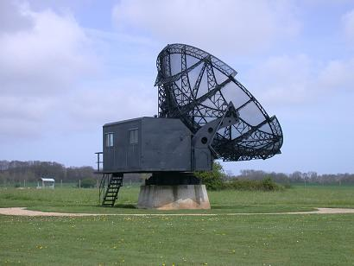

Radar station at Douvres-la-Délivrande

By kind permission of the Dover Mercury, (KMG) published: 17th May 2007

