What’s in a Name?
Dover around the World by Lorraine Sencicle
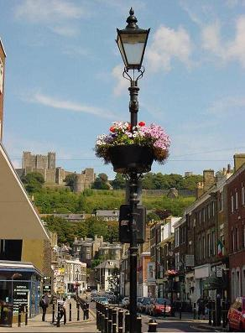
A reader of the Dover Mercury wrote and asked me about the origin the name Dover and how it had spread around the World. Briefly, I told him, there are at least two likely origins of the word Dover, the Latin - Dubris, meaning waters and was the name given by the Romans.

On the other hand, some believe that Dover comes from the old Scandinavian meaning a ravine, gap, gorge or a crevasse between cliffs. This would put the origin of the word to the days Vikings - who came to Kent after the Romans, by which time our town was called Dubris. Perhaps the Vikings changed Dubris to Dover?

Of interest, Douvres as in Douvres-la-Délivrande, Calvados, France, probably comes from the Celtic Dubras, also meaning ‘waters.’ Further south, in France and in northern Italy, there are more Dovers of various spellings, these may derive from Dubris or the Gaulish Dubron, again meaning ‘waters’. However, in Turkey, where there are two Döver’s pronounced Doeuver, it means ‘to beat or hit a person,’ for instance the boxer beats/hits his opponent!

As spelling tended to be phonetic in old manuscripts, up until the 18th century Dover, England, was sometimes spelt with an ‘o’, i.e., Dovor. In some documents Dover and Dovor are used, however, in more recent times the spelling Dovor has been used, in my opinion, for affectation.
To date I have been able to identify some 87 Dover’s around the World. Originally there were 88 but by a referendum the folks of Dover, Ocean County, New Jersey, changed their name to Toms River, a couple of years back! However, of note, the State Capital of Delaware is called Dover, after Dover, England. Actually, most Dovers derive their name from Dover, England. This is mainly due to émigrés who set up homes in places where there were high cliffs. Scandinavian émigrés have also influenced the names of some of the Dovers for similar reasons. However, those places where the original émigrés came from Dovre, Norway, have spelt it the Norwegian way. Later, most changed this to Dover but Dovre, Wisconsin, US, has maintained its Norwegian origins.
A further influence on the spread of Dover in the US and Canada, comes from émigrés who first settled in or near Dover, New Hampshire, which was originally named after Dover, England. One account of a Dover in the mid-west US, tells that the origin is attributed to the founding father coming from Dover - Somerset! Further research, on my part, revealed that the original inhabitant had come from Somerset, but on arrival in the US lived for a while in Dover, New Hampshire!
My Dovers Around the World project was begun in 2006 and as it has developed three distinct parts. The original project was, and still is, to research and make contact with at least one respondent in each of the different Dovers for a local perspective. The resulting article to be published in a local newspaper.
Once published, the second part, is to reproduce the articles on the Dover Society website: to enable other people, throughout the World, to read about the different Dovers.
The third part is to develop the relationship with the different Dovers for civic and educational purpose
Although making contact with a respondent is not always easy, getting photographs of sufficient resolution to be published in a newspaper is very difficult. Nonetheless, to date I have managed to cover over 40 Dovers!
The Dover Society, like the Mercury editorial, are very keen to support the project, so the second part of my project has not produced any problems. When the articles are reproduced on the Dover Society website, I inform all of the respondents.
Sadly, the final phase of the project, developing the relationship of different Dovers with Dover England for civic and educational purposes has not been so successful. Although, many of the different Dovers have been keen to foster this, except for Dover Grammar School for Boys, the enthusiasm here in Dover England, has been minimal.
Albeit, over the period I have been covering the different Dovers I have made friends with numerous other ‘Dovorians’ throughout the World and have learnt lot about their countries, localities, society and politics. It is amazing how we all share the name of Dover but how different we are from each other.

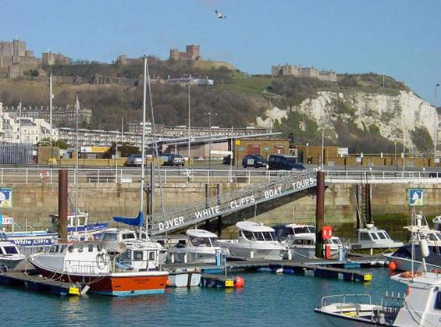
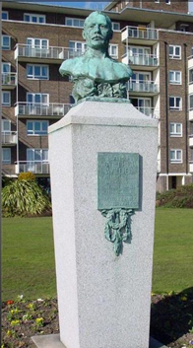

Captain Webb Old Dover Marina and White Cliffs
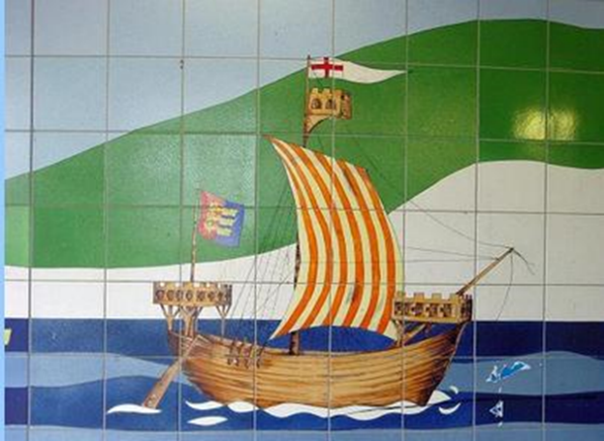
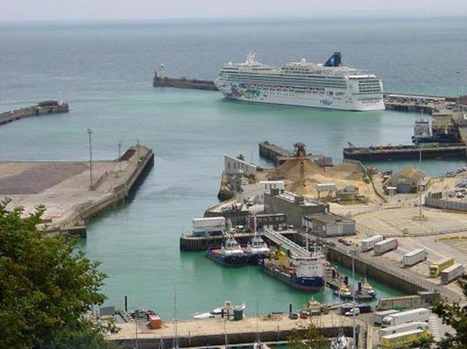
Cruise Ship Western Arm Tiled mural Dover underpass to seafront
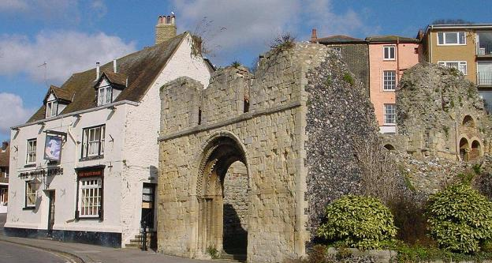
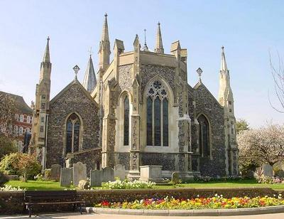
St Mary’s Church The White Horse Inn

By kind permission of the Dover Mercury, (KMG) published: August 2010

