Dover, Illinois, USA
Dover around the World by Lorraine Sencicle
Although the capital city of Illinois is Springfield, most of us tend to connect Chicago with the State. Illinois traces its history back to prehistoric times when an early civilisation, which has left thousands of mounds, lived there. More recently Iroquois American Indians roamed the land, followed by French explorers and when settlers moved in Illinois became a French possession. The State then came under English rule followed by being part of the Virginia, Indiana Territory and finally it was proclaimed Illinois Territory in 1809 and was admitted into the Union in 1818. Most of Illinois is flat with fertile soil and the early settlers were farmers. Growth was rapid to the detriment of the Native Americans who had lost their lands in a disputed treaty of 1804.
Sylvester Brigham arrived in the Dover area about 1830 but due to the Blackhawk War (1832) against Sac and Fox Native Americans, he and the other settlers at first lived in a fort some distance away. After the war he laid out the new settlement and called it after his home of Dover, New Hampshire (for further details see Dover, New Hampshire). Eli Lapsey was the first inhabitant and by 1837 the community was sealed as a town which included the granting of a Post Office which guaranteed a notation on maps.
The town quickly prospered and in 1840 homes within it were used as safe houses on the ‘Underground Railroad’ or ‘Liberty Line’ as it is sometimes referred to. Lasting for about eighty years the ‘Railroad’ consisted of a series of safe houses where fugitive slaves, usually young adult males without a family, could rest and hide from bounty hunters on their way to Canada and freedom.
The escapees travelled by night to avoid detection using the North Star for guidance. On arrival in a town like Dover, Illinois, they would seek out a safe house and my respondent in Dover, Sandy Vail Elmore, tells me that her first home was one such house. Typically, the escaping slave would be hidden in an upstairs cubbyhole where beds would be pulled across the entrance to hide its existence. The actual number of slaves assisted was once thought to be more than 60,000, but this is now believed to be an exaggeration. Slavery was abolished by the 13th Amendment to the US Constitution in 1865.
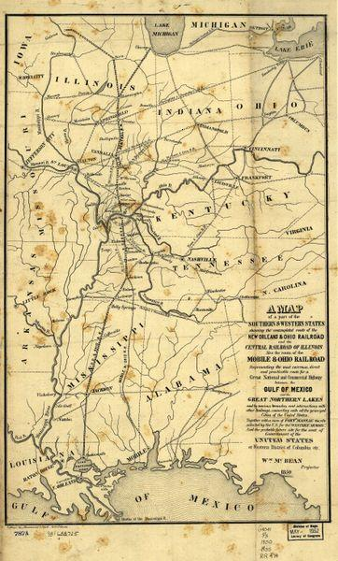
Illinois central railroad

Dover's first church was formed in 1838 in Sylvester Brigham’s home, and the present village Church, still considered one of the most attractive in the state, was erected in 1850. The town, at this time was prosperous but between 1851-1856 the Illinois Central Railroad was built, bypassing Dover by some two miles, and its importance declined.
In 1857 the remaining citizens met to consider the feasibility of setting up an academy in order to attract settlers. With 41 shareholders, the Dover Institute opened in 1858 and the following year was renamed the Dover Academy but closed before the turn of the century. The building was taken over by ‘Congregationalist Deaconess’, to provide an orphanage, however, in 1912, two of the children, playing with matches, burnt it down. It was rebuilt but in 1964 closed and was sold for refurbishment as a private house.
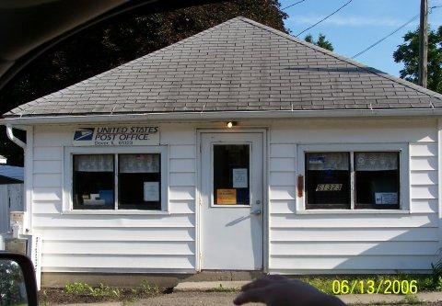
Illinois Post Office

Today, Dover has a population of about 135 (2020 census) and is predominantly a ‘bedroom’ community for commuters to Princeton, some 5 miles away. In Dover, there is Elmore Electric, an electrical contracting business and employs 27. Also, Ultra Foam, a small factory that makes foam for cushions. East Bureau Creek runs through the township, along which there is still much valuable timber and surrounding the land surrounding the township is well cultivated by several farms.

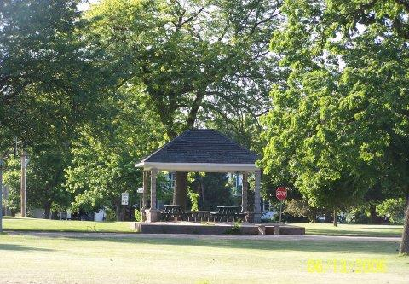
Illinois commons shelter

Thanks to: Sandy Vail Elmore

By kind permission of the Dover Mercury, (KMG) published: 30th August 2007

