Dover Township, Lenawee County, Michigan, USA
Dover around the World by Lorraine Sencicle
The State of Michigan, besides Detroit, is also famed for more than 11,000 lakes. Indeed, much of the State’s boundaries are formed by four of the Great Lakes - Superior, Huron, Erie, and Michigan. Further, Michigan is physically divided by the lakes Michigan and Huron into Upper and Lower Peninsulas. The State also boasts of at least five Dovers!

The area that constitutes Michigan has been populated from earliest times. When European settlers arrived the principal Native Americans were the Ojibwa, living in the north who were primarily hunters and fishermen. There were also the Anishnabe, Miami and the Potawatomi, who were farmers and lived, in large, stockaded villages in the south. In-between were the Ottawa people who mainly earned their living through trade as well as the descendants of the once mighty Huron people, the Wyandot. Their population was estimated at 10,000 to 30,000 before the Europeans brought smallpox that decimated their society. The Huron grew corn, beans, squash, tobacco, and sunflowers while fishing was their major food source.

The first of the Dovers I am going to look at is in Lenawee County at the southern end of the Lower Michigan peninsula. The Dover Township is about 35 square miles and has a population of about 1,658 (2021 census). Townships, in the US, are tracks of land not specific places, some sustain villages while others support a few homesteads and farms and others are uninhabited.

The flat fertile land of Dover Township provided one of the earliest settlements by Europeans in the State. Israel Pennington made the first land claim on 27 May 1830 followed, four days later, by Samuel Warren. Israel sold his 240 acres shortly afterwards, but Samuel settled there with his family. About four years later a man named Robb opened a two-room tavern, which was noted for offering sleeping accommodation without any beds!

The early history of the Township is one of hardship with pioneers trying to make ends meet. Typically, seventeen-year-old Martin Stockwell left home in Cayuga County, New York, with only $3.50 and a sack full of provisions his mother had packed. To save money, he worked his steerage with the intention of going to Detroit, but the captain of the ship, who had befriended him, suggested that Martin disembarked at Toledo. Taking this advice, the young man undertook the thirty-mile trek to Adrian, the county town of Lenawee, but on the way sought a night's rest at Dover - possibly in the tavern with no beds!

Albeit Martin decided to stay and soon found work. Four years later he had earned enough money to buy forty acres of virgin land and through hard work, eventually built one of the finest houses in the Township and became a pillar of the local community.
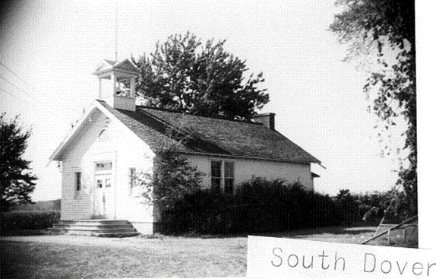
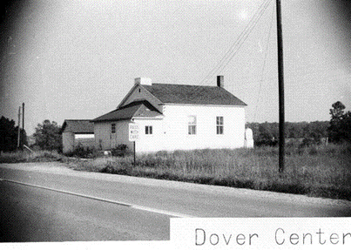

Originally called Unionville, the Township was renamed Dover on 22nd April 1842, when the first post office opened. By 1863 it had 1,400 inhabitants, a Methodist and Baptist church, two steam mills and three men all claiming to be the Justice of Peace! In the west of Dover, a settlement grew, and another post office opened on 8 March 1837 - this was named East Dover! Confusion ceased when the settlement changed its name to Clayton on 17th July 1849. These days Clayton straddles the border of Dover and the adjacent Hudson Township.

The opening of the Lake Shore and Southern Michigan Railroad provided access to the outside world, and quickly led to Clayton becoming a village. With this prosperity the Township boasted of two one-room schoolhouses which remained in use up until the 1950s (pictures). These had one teacher each and the ages of the children taught ranged from seven to thirteen or even older. The Township of Dover remains a sparsely populated area heavily involved in farming. Its village, Clayton, has population of 326, and according to my respondent has a lovely midtown park.

Website: https://www.dover.lenawee.mi.us

Thanks to:
Carol Stevens, President of the Lenawee County Family Researchers.
Jan Richardi, Lenawee County Historical Museum
School photos: Courtesy of the Lenawee County Historical Museum

By kind permission of the Dover Mercury, (KMG) published: April 2008

