Dover Barbados, Windward Islands, Caribbean
Dover around the World by Lorraine Sencicle
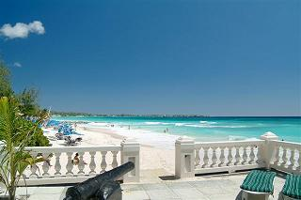
Barbados Sandy Beach

Some years ago, I was undertaking an academic piece of research which included looking at the very early history of Barbados, some of which I have included in this article. At that time, my stay in Barbados was brief, but when I was seriously ill, in 2002, and undergoing some very uncomfortable treatment I would mentally escape to the island. As soon as I was well enough, I wanted to return, which we did, and I was not disappointed.
The coral island of Barbados is part of the Windward Islands of the Lesser Antilles in the Caribbean. The original inhabitants probably arrived around 1600BC, but it is known that the Amerindians, from Venezuela, settled about 350AD. The Arawak Nation, whose settlements can still be seen, followed them. However, around 1200 the Caribs, also from Venezuela, invaded driving away the Arawaks.
The Portuguese explored the island in the 16th century, and it was they who called it Barbados, meaning ‘bearded’, but why is a matter of conjecture. The Spanish followed and it is believed that one or both the Spanish and Portuguese took Caribs as slaves that prompted the remainder to make a mass exodus.
Captain John Powell landed, at a place now called Hole Town, in 1625 and claimed it for England. His expedition found only feral pigs. Two years later Powell's brother, Henry arrived with 80 English settlers and more settlers quickly followed. By 1629 the island had a population of 2,000. That year saw William Tufton - of the East Kent family - appointed Governor of Barbados. It was William Tufton whom I was researching. He arrived on the island in December 1629 and on the 21st of that month held a court where 140 grants amounting to 15,870 acres of land were granted. Tufton also claimed a plantation near the then capital of Holetown for himself. Tufton, however, was not totally popular especially as he objected to the cruel way some planters treated their servants. When a number of planters were brought before the court he presided over, accused of murder by brutal treatment were found guilty he sentenced them to death. However, shortly afterwards he commuted the sentences sent them back to England. On arrival in England, they complained about Tufton and Henry Hawley, a man with a reputation of being ruthless was sent out to replace Tufton. This, Tufton appears to have accepted without complaint - but this could be because documents have been lost. Albeit, Hawley had him arrested on trumped-up charges and he also, as governor, sat in judgement at Tufton’s subsequent trial. Needless to say, Tufton was found guilty, sentenced to death and executed in May 1631. Tradition has it that Tufton was shot under the Silk Cotton Tree in the St Mary’s Churchyard, in the now capital Bridgetown. At the time though, Bridgetown was a swamp and the Church had not been built. Nonetheless, today the most significant aspect of the case is that Tufton's execution is now seen by a number of academics one of the few legalised murders in the English justice system. At the time when Tufton was Governor the island was divided into six parishes each with a church, on the English style. Henry Hawley introduced the House of Assembly in June 1639 but his rule, according to Barbadian
historians, was one of, “terrorism, court martials, hanging, flogging, branding and cropping of ears of delinquents.” During this time, the capital was Doncaster but at the village of Oistins, the Barbados Charter was signed in 1652, close by is Dover. The island became a Crown possession in 1663 and a place called Indian Bridge at the time, after several changes of name, became the present capital, Bridgetown.

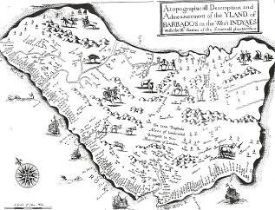
Barbados map
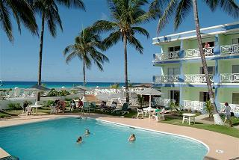
Barbados hotel and pool
Pieter Blower introduced sugar cane to the island in 1637, and planters started to switch to the vegetable from growing tobacco and cotton. This led to a massive importation of slave labour from Africa and the UK - the latter included religious dissenters, gypsies, and those serving penal servitude. For the next few centuries, the sugar industry boomed. Although, slavery had been abolished in Britain in 1807 this did not apply to the colonies. In 1816 some 20,000 slaves from 70 Barbadian plantations rebelled but the rebellion, the largest in the island’s history failed. 120 slaves were killed and a further 144 executed. Nonetheless, in 1834. In 1834 slavery was abolished throughout the British Empire.
The sugar industry, already in decline, carried on the downward spiral. Then the island was hit hard by the economic depression of the 1930s. There was civil unrest but following increasing liberalisation of the electoral system to the descendants of the emancipated slaves; the island started to thrive. Barbados was granted internal self-government in 1961 and became an independent nation, with the Queen as Head of State, on 30th November 1966. Since that time Barbados has one of the highest standards of living in the Caribbean and Dover has exploited its tourist potential. The village has one of the finest beaches in Barbados, attracting young families, swimmers, bodysurfers, windsurfers and board surfers. It also has become famous as the ‘Gap’ for its restaurants, lively nightlife and shopping.
Thanks to: Jeff Kinch and Colin Jordan of the Dover Beach Hotel and also the University of the West Indies, Barbados.
website: www.doverbeach.com
By kind permission of the Dover Mercury, (KMG) October 2008

