Dover Bridge Near, Leigh, Lancashire
Dover around the World by Lorraine Sencicle
As a child I spent two very happy years living near Dover ... in Lancashire!
From where I lived Dover was just a walk along the Bridgewater Canal. Why the hamlet was called Dover is lost in the mists of time, but it is believed that the name may have come from Dover, Kent, as the Lords of the nearby manor of Abram, had strong military connections with our town.
The Bridgewater Canal received Royal Assent on 23rd March 1759 to enable coal from the Duke of Bridgwater's mines at Worsley, west of Manchester, to be transported to that city and sold cheaply. In 1795, the duke received permission to link his canal to the Leeds and Liverpool canal at Leigh, some 7 miles west. The latter is the longest single canal in Britain and opened in 1777. In 1820 the Leigh branch opened connecting it to the Bridgewater canal with locks at Dover.
The opening of the canal network brought the cotton spinning and weaving industry to south Lancashire. The rich coal seams in the area fuelling the burgeoning industry. The area around Dover, because of its strategic location on the canal network and its rich coal seams, quickly grew and was first absorbed into Abram then into Leigh itself.
The coal seams were exploited to the full as one after the other shafts were sunk at more pits. With this came mining accidents and on 22nd August 1908, at the Maypole pit, close to Dover, 75 lives were lost following an explosion. Amongst the dead was a member of my family.
Not long afterwards heavy coal mining subsidence in the area around Dover affected the canal which led to more locks being built between Dover and Wigan. Then, it was decided to tackle the problem of subsidence by banking, using spoil from the collieries and Dover Locks were removed altogether. The collieries were abandoned in 1959 and the last coal was transported on the canal, from Bickshaw/Bickershaw Colliery at Leigh to Westwood Power Station, in 1972.Since then the landscape has been painstakingly restored as parkland and Dover has become a haven for wildlife. The canal, which once had to climb a hill by the use of locks, now stands above the surrounding countryside. It has been shored up, appropriately by what is left of the pit waste. All that remains of the hamlet now is a pub called the Dover Lock Inn.

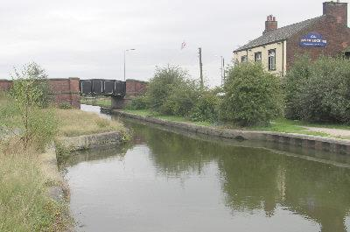
Dover Bridge Leigh and the Dover Lock Inn.
Thanks to Alan Davies of Leigh Library.
website
By kind permission of the Dover Mercury, (KMG) published: 6th June 2008

