Dover Calgary, Alberta, Canada
Dover around the World by Lorraine Sencicle

Alberta is the westernmost of the Prairie Provinces of Canada and is wholly an inland territory. Named for Princess Louise Caroline Alberta, daughter of Queen Victoria and the wife of Marquis of Lorne (later the 9th Duke of Argyll), Sir John Douglas Sutherland Campbell. It entered the Confederation of Canada on 1st September 1905 and enjoys the title of ‘Sunny Alberta’, for the number of hours of sunshine it enjoys.
For centuries the area was occupied by the Plains Native Americans, the Blackfoot, Blood, Peigan, Atsina, Cree, Sarcee and Assiniboine. The first Europeans were French fur traders who arrived about 1750 and the establishment of trading posts from the 1780s encouraged settlements. From 1821 the Hudson’s Bay Company, headed by John Jacob Astor controlled the region. His great-grandson, of the same name, was the MP for Dover from 1922 to 1945 and lent his name to Astor Avenue and Astor College.
The Hudson's Bay Company administered the area until 1870 when the new Dominion of Canada bought the company’s lands and organised them as the Northwest Territories. Lawlessness, exacerbated by trading whisky for bison hides with the Native Americans, led to the establishment of the Northwest Mounted Police (later the Royal Canadian Mountain Police) to keep order. They concluded treaties with the Native Americans and also established Calgary in 1875.
The opening of the Canadian Pacific Railway in 1883, linked Calgary to the rest of Canada, and the population increased. The city cashed in on the cattle herders working the North American plains, by becoming the major meatpacking centre. This, together with offers of free or cheap land by the government encouraging immigration and cattle ranches soon proliferated.

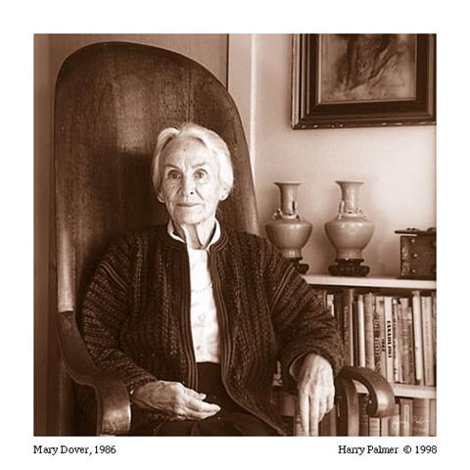

Mary Dover
In 1912 Calgary introduced the 10-day annual Stampede, which these days attracts about 10,000 people each day. One of the early and consistently active Stampede volunteers (organisers) was Mary Dover, (1905-1994), the daughter of a prominent Calgary family. Mary was renowned throughout Calgary, receiving the Order of the British Empire, in 1946, for her service in the Canadian Women’s Army Corps during WWII. She was also a Calgary City Alderman from 1949-1960, except for three years from 1953; as well as receiving an honorary doctorate from the University of Calgary and the Order of Canada.

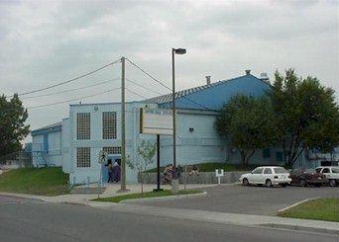

The strong community spirit that is Dover is also annually celebrated with an Easter and Halloween parties and most popular of all, Dover Days..
These three-day events take place in the first week in June and include sports tournaments, a parade, carnival, dance and a pancake breakfast. In the evening there are dances and other social events and as the community has about 2,405 hours of annual sunshine, the weather is almost guaranteed to be good!

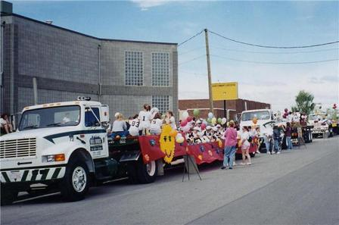

The strong community spirit that is Dover is also annually celebrated with an Easter and Halloween parties and most popular of all, Dover Days..
Thanks to ; Maureen McDougall Community Co-ordinator
Jasper Twila, Executive Assistant to Dover's Alderman, Joe Ceci
website
By kind permission of the Dover Mercury, (KMG) November 2009

