Dover, Delaware, USA
Dover around the World by Lorraine Sencicle
In 1977 Margaret Turner of Archers School went on an exchange visit to Lake Forest High School, Dover Delaware, spending three weeks there. In those days our town was keen to undertake such visits and along with Dover Town Council, I am working to re-establish such links.
Dover is the State capital of Delaware, one of the South Atlantic states of the United States, bounded on the north by Pennsylvania, on the east by the Delaware River, Delaware Bay, and the Atlantic Ocean, and on the south and west by Maryland. Known as the First State for on 7th December 1787, it was the first of the original 13 states to ratify the US Constitution. The State was named in honour of Thomas West, 3rd Baron De La Warr, the first colonial governor of Virginia. Before the Europeans arrived, the Lenni Lenape people, later known as Delawares, occupied what is now the State but as white settlements encroached on their hunting lands, they gradually moved to Pennsylvania, Ohio, and finally beyond the Mississippi River. The first European settlers were Swedish who founded Fort Christina (present-day Wilmington), and then the Dutch seized the settlements followed by the English.
These days Delaware is made up of three counties, one of which is Kent County, and it is here that Dover is situated. The city has an estimated population of 34,120 and still growing. It was founded in 1683 by William Penn, to whom land comprising of what are now the States of Delaware and Pennsylvania, was granted by Charles II. A special commission of the Delaware General Assembly in 1717 officially laid out the city, which makes it the oldest Dover in the US.

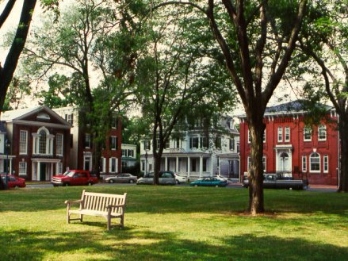
The Green

During the American Revolution (1776-1783) the central square of Dover, known as the Green, was the mustering point for Delaware’s troops.
In the cemetery nearby is a cenotaph to Caesar Romney, one of the heroes of the Revolution.
During the American Civil War (1861-1865), Delaware sided with the Union, but many of the State's residents were Confederate sympathisers and the State retained slavery. In Dover, the sympathies were with the slaves, hence the city became a ‘stop’ on the ‘Underground Railroad,’ which helped slaves escape to freedom in Pennsylvania and New Jersey (for further details see Dover Illinois).
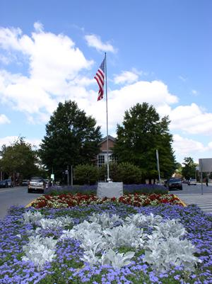
Delaware’s War Memorial
Today, the Green, defined by Penn in his original building order, is still central to the city. Here, for nearly two centuries, stood the coaching inn which served travellers on the King’s Road to and from Philadelphia and nearby is Delaware’s Old State House, the second oldest still in use in the USA.
In 1802 a Franco-American industrialist Eleuthêre Iréée du Pont de Nemours, opened a gunpowder factory near Wilmington and started what was to become Delaware’s most important industry, the Du Pont Chemical Company. The catalyst for Dover’s expansion was the completion of the Dupont Highway in 1924. Then in 1937 Latex Corporation moved to Dover followed by other light industries such as the ILC Dover, which manufactured the Apollo and Skylab space suits.
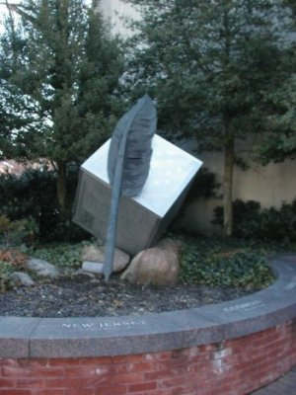
Delaware Block and Quill
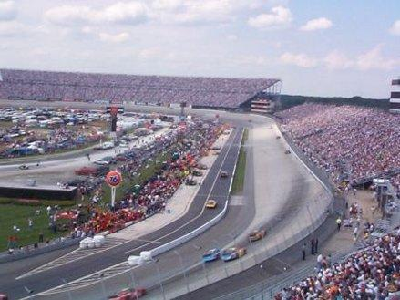
Delaware’s Speed track

website
Albeit, it is Dover’s administrative role, to both Kent County and the Delaware State that provides much of the employment. Nearby is the Dover Air Force Base, which is the largest military freight terminal in the world and home of the 512th Airlift Wing. It also houses the US military’s only mortuary in the continental US. It is here where the remains of soldiers killed in Iraq and Afghanistan conflicts are brought. Dover, because of its history, has many historical sites besides the ‘Green’ and also boasts of a major horseracing track on nearby Dover Downs. Although the city has a population slightly less than ours, it has most sports and entertainment facilities, four school boards, five colleges, and a police force of 80 uniformed officers! It is also the only State capital with a volunteer fire department.
Thanks to: Coleen Colman, The Mayor’s Office, City of Delaware

By kind permission of the Dover Mercury, (KMG) published: 11th October 2007

