Dover, Dutchess, New York, USA
Dover around the World by Lorraine Sencicle
On 24th February 2007, the start of the bi-centenary celebrations in Dover, New York State, took place. The celebrations will end with a fitting ceremony on 9th November, but the highlight will be a festival and parade on 19th May. My respondent Donna Hearn, tells me, that if anyone from Dover, England, turns up for the celebrations in May, they will be “entertained royally!”

Dover is situated in the mid-Hudson valley, upstate New York. An area renowned for its picturesque landscape, pretty towns, and mansions of old-money New Yorkers. Although Dover was officially incorporated 200 years ago it has been in existence from the beginning of eighteenth century and it is generally assumed that a Richard Sackett gave the town its name.
On March 11th 1703 Richard Sackett petitioned the New York government for permission to purchase about 7,500 acres of land in eastern Dutchess County (sometimes spelt Duchess), New York State, from the Algonquian native Americans, which included the Pequots. The Algonquians, with the exception of the Pequots who resisted European encroachment, lived in peace with the settlers. It is said that Sassacus, chief of the Pequot tribe, hid in a cave near Dover, now called the Stone Church, to escape the English. This cave is now a state landmark and was given the name because the arched opening resembles the entrance to a medieval cathedral. The valley where Sackett settled was lined with marble and limestone and this, it is said, reminded him of the white cliffs of Dover England. It is probably correct, for Sackett is a common East Kent name, and Jeffrey Sackett was the Mayor of Sandwich in 1674, 1687 and 1693. Not much is known about Richard Sackett other than he was employed by the British Government as a procurer of naval stores, specialising in trees for ship masts and tar.
By the mid-eighteenth century a cattle trail was established along the Hudson valley from New York to Albany and Vermont. In 1750 John Preston opened an inn for cattle drovers using this trail. Although extended and altered, the Old Drovers Inn is as popular today as it was then and still bears a primitive painting with the inscription, ‘Free conscience void of offence.’ This has been adopted as the town’s motto.
By the end of the century Pawling, a town to the south of Dover, became supreme and Dover was just classed as a hamlet with an inn and Dutch subsistence farmers. However, on February 20th 1807, Dover succeeded in becoming a town in its own right.
Six years later one of Dover’s famous citizens, Benson J Lossing was born. Illustrating his own books, he wrote a pioneering history of the American Revolution as well as studies of the American Civil War and the War of 1812. Lossing died in 1889 and is buried in the town.
In 1832 the most illustrious Doverite, General John Henry Ketcham was born. He grew up and became a Republican member of the House of Representatives until his death on 4th November 1906. Ketcham also became a Major General during the American Civil War (1861-1865) and is also buried in Dover. In 1904 Ketcham donated two fire hose carts and his name lives on in the town through the J H Ketcham (fire) Hose Company. In 1815 Thomas Tabor asked a local carpenter, Mahlon Wing, to build a house for him. Mahlon eventually married Tabor's daughter, Sally, and moved into the house, had eight children and ran a thriving farm. In 2002 the Dover Historical Association gave the house, the only one listed, to the town.
The Industrial Age came to Dover with the Harlem Railroad in 1850. This fostered the growth of iron and marble industries and transformed agriculture to dairy farms for the milk markets of New York. The hamlets of Dover Furnace, which grew up around the iron foundries, South Dover and Dover Plains are part of Dover, the population of which is 8,379 (2021 census). The legendary Appalachian Trail traverses the town and where it crosses the Harlem railroad there is a flag stop to allow hikers to take the train journey to New York and for New Yorkers to take a break in this beautiful part of the State.
website

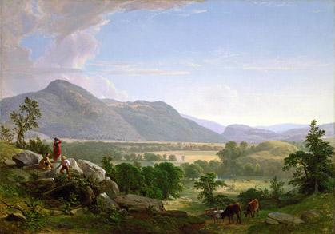

New York Dover Plains by Asher B Durand

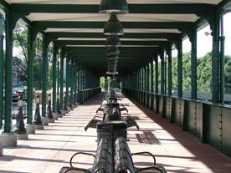
New York Railway Station

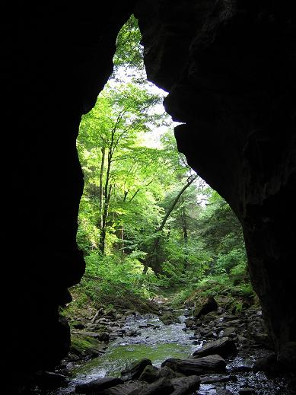
New York Stone Church shadows

By kind permission of the Dover Mercury, (KMG) published: 5th April 2007

