Dover Farm School, South Africa
Dover around the World by Lorraine Sencicle
In 1970 a sugar cane farmer, Owen Johnson, with connections to Dover, England, set up a school to cater for the children of his workers 3 km north of Empangeni, KwaZulu-Natal, South Africa. The school, named after Dover, England, is now a major education establishment, that consistently gets high results compared to the other 905 farm schools in KwaZulu-Natal province.
It was in 1994 that Natal Province was renamed KwaZulu-Natal, in a belated attempt to acknowledge the fact that the Zulu heartland is within the province. Natal had been proclaimed an English colony in 1843, two years later it became part of the Cape Colony, but again became a separate colony in 1856. About a century ago the bloody battles of the Anglo-Boer and Anglo-Zulu wars were fought in the province. Now, besides being an area where sugar and eucalyptus are grown, it is well recognised as being the Zulu heartland.
Farm schools were started in the days of Natal Province on land owned by sympathetic farmers with teachers paid by the Education Department. Thus, the standard of education the children received varied considerably, as did the facilities. Further, up until 1990, legislation restricted these schools to primary education, which meant that many pupils left with only a basic education due to the lack of high schools in rural areas. Today, the situation has not changed much in many areas.
Dover Farm School originally consisted of one teacher, two rooms and 20 pupils but by 1990 the number of pupils had increased to 120 who were taught in two rooms by two teachers. It was in that year that Sipho ‘Tiger’ Ndlovu, was appointed headmaster. Born in Soweto, Tiger was an activist against apartheid and was forced to leave his homeland in 1976 for Natal where he continued his fight. He became a teacher and joined Dover Farm School in honour of a promise he made to his comrades during the anti-apartheid struggles, although it was considered a backward career move.
The farm’s manager, M.E. Furby, had a vision for the Dover farm school and with Tiger they raised a total of 1.2m Rand. With this, on land donated by the Umhlathuze Valley Sugar Board, they built a school consisting of 12 classrooms, an ablution block, staff room, strong room, science laboratory and a classroom library.
In 1996 Dover school was allowed to teach at High School level and has, since then, had a pass rate in all subjects equalling the local private school sector. In 1999 computers were introduced to the school and Tiger sought to link with other schools throughout the world. This has enabled his pupils to get to know and understand children from other countries as well as learning how to use computer. Although this has proved very effective to date, no school from Dover, England has responded. It is hoped that on the publication of this article a Dover school will contact me, so I can put them in touch with Tiger.
Dover farm school now has well over 700 pupils and boasts of a nil drop-out rate. Recently, even though they didn't have a science teacher, they still managed 100% pass rate in the national physics exams by utilising locals with knowledge in the subject!
The schools mission statement is: To Provide Excellent and Relevant education to our students working to the highest professional standards using knowledge, skills, attitudes and technology that exemplify that all people are valuable, capable and responsible
website
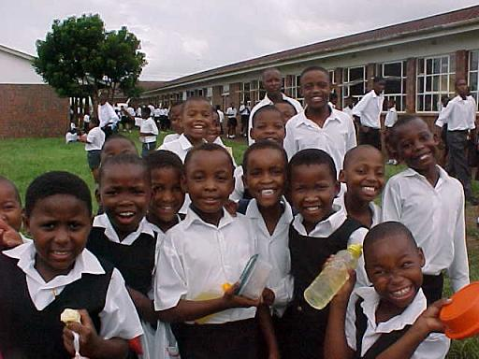
Young school children

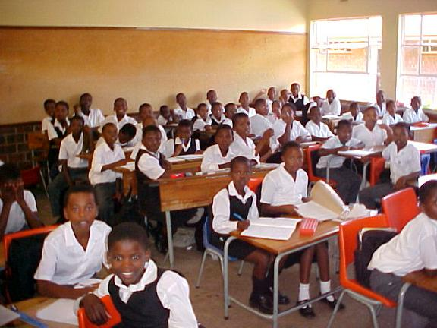
School classroom

By kind permission of the Dover Mercury, (KMG) published: 16th November 2006

