Dover Foxcroft, Maine, USA
Dover around the World by Lorraine Sencicle
Situated at the extreme northeast of the US, Maine was originally inhabited by some 20 related Algonquian tribes united as the Wabanaki (people of the dawn). By 1658 Massachusetts had asserted its jurisdiction over the area and in 1691 it became part of that State.
Because of its thickly forested terrain, European settlers were slow to move inland. However, in 1794, Charles Vaughan and John Merrick purchased a deed for a tract of land, which they called after their hometown of Dover, England. Shortly after, Abel Blood made a clearing, but the first actual settler was Eli Towne, who came from New Hampshire in 1803.
Eli Towne now has folk hero status, and many stories are told of him. A soldier in the American Revolution (1776-83) he became a great hunter and on one occasion fired upon and wounded a bear that was swimming across a pond. As the animal approached the shore Towne's dog swam out to the bear. The bear lashed out at the dog’s head pushing it under the water. Upon which, so the story goes, Towne rushed into the pond and grabbing the bear’s head plunged it under the water, crying out fiercely, “drown my dog, will you!” The bear was soon overcome and the dog was rescued.
Although Maine wanted early separation it was not until 1819 that the Massachusetts General Court agreed and it was admitted as the 23rd State of the Union in 1820. Two years later Dover was incorporated into a town and Eli Towne was chosen as Clerk and also a Selectman (similar to our Councillor).
A bridge was built across the Piscataquis River (Indian word for rapid running water) and also a dam. A sawmill, wool mill and a gristmill for grinding wheat were next built along with and a potash factory. The town was in business!

Afterwards the town prospered on its pine and in 1922, joined with Foxcroft, across the Piscataquis River to form Dover-Foxcroft.
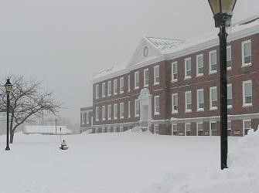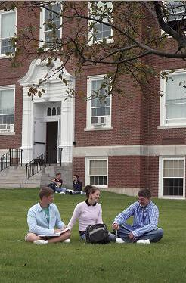
Foxton Academy

Foxcroft Academy an independent day and boarding school founded in 1823 set the standard for the development of secondary education in the New England. So, it was not surprising that in 1903 the town of Dover closed its public high school and sent their students across the river to the Academy. Today, Dover-Foxcroft continues the practice of paying the tuition fees for all secondary students to attend the Academy, which also accepts tuition paying students from fifteen other Maine communities, as well as 80 plus boarding students from 11 different countries.

Dover-Foxcroft has a population of 4,422 (2020 decennial census) and is run by an elected seven-person Board of Selectmen and is administered by a Town Manager. Besides being the main shopping centre for the county, it is also the home for the Moosehead Furniture Company, Pleasant River Lumber Company and Creative Apparel. The latter makes military uniforms. The area also has some of the best farming land in the district growing potatoes, corn and grain. However, the most prosperous part of Maine is the southern coast, which is popular with tourists. Inland Maine by contrast, has problems and according to the 2020 US census about 16.2% of the population of Dover-Foxcroft were below the poverty line including 13.3% of those under the age of 18. This led to the publication, in 2005, of a 200 plus page Comprehensive Plan. The Plan makes for interesting reading but I found it sad that a frontier town to an immense and beautiful forest abounding with white-tailed deer, moose, black bear, beavers, muskrat, bobcat, otter and red and grey squirrels, could not attract US tourists.
website
By kind permission of the Dover Mercury, (KMG) published: January 2007

