Dover, Lafayette County, Missouri, USA
Dover around the World by Lorraine Sencicle
In 1643 French missionaries ventured down the Mississippi from the north and fur trappers and prospectors followed. At the time, the area between the junction of the Mississippi and the Missouri rivers was extremely fertile and the sophisticated Cahokia native Americans, up to 100 years before, were inhabiting the area. European settlers moved in during the early part of the nineteenth century. Missouri was admitted into the Union as a slave state in 1821.
Dover, Lafayette County, Missouri is a small town that is located about one mile south of the Missouri River, 10 miles from the historic town of Lexington. The 2021 census for the US gave the population as 115 people, 37 households or 25 families.
The story of the town’s birth is a romantic one. Solomon Cox and John Lovelady left Virginia to seek their fortunes in the West. Mary Cox, Solomon’s sister, was in love with John and wanted to go with them, but because of the possible hardships involved, they refused. A determined young woman she decided to follow staying far enough behind so they did not know what she was there, but near enough in case of danger.
After a few weeks, when the men were too far from Virginia that Mary would not be sent back, she made herself known to them. This proved a wise move, and she was allowed to travel with them. About the same time as Mary, John and Solomon arrived at the place they were to call Dover; other settlers arrived including a Padre who married Mary and John the following year.
Because the settlement was close to the Santa Fe Trail, which took countless prospectors’ west in search of gold, it quickly grew. In 1835 the town was platted with a Main Street 90ft (approx. 30 metres) wide. By this time there was a blacksmith, liveryman, pool hall, hotel, two general stores, a doctor and a newspaper, The Dover Deliverance.

The American Civil War (1861-1865) took its toll on the town as in Missouri feelings were particularly bitter and there are many interesting tales in the local history book. The story that caught my eye concerned Jesse James, who is also featured in my article on Dover, Tuscarawas County, Ohio (Dover Mercury 5th July 2007). James was born in Missouri and a year after the end of the Civil War he and his brother carried out the first successful ‘peacetime’ daylight bank robbery in the US. Many more were to follow until James was shot and killed by a member of his gang in 1882. Throughout this time James became an idealised folk hero.

Apparently, one evening, during his exploits, he arrived at the home of a Dovorian and asked for food and shelter. He was made welcome given supper and a bed. The sleeping fourteen-year-old son of the household already occupied the latter. Early next morning James left but at the breakfast table their famous visitor was the subject of conversation. When hearing that he had shared a bed with the outlaw, the fourteen-year-old remarked, “well I be darned I always wanted to see Jesse and I slept with him all night and I never even saw his face!”

During the time when settlers moved into the area, two Frenchmen, Ely and Curtis were travelling up the Missouri River and spotted an idyllic stretch of land near Dover, which, local legend says, they called “Terre Beau.” The name stuck and in 1858 the Terre Beau Winery was planted and is still a thriving concern.
By 1900 Dover was incorporated as a village with a population of 250 people and coal was discovered. Prospects were so good that in 1906 the Dover Bank opened with a capital of $10,000 and the hamlet of North Dover evolved around the mine.
The nearby Missouri - Pacific railway also provided work and the result of plentiful well-paid jobs was a population explosion - Dover was at its most affluent. In the late 1920s government projects were begun along the Missouri River but in 1932 the mines closed, the river contract work dried up and the railway declined. Dover bank closed and economic depression took its toll on the town.
Nonetheless, even though there was rapid fall in population from which the town has never recovered, it is proud of its service to the US. In WWII eight locals were killed fighting for their country and in the Vietnam War, two died.

Today Dover is in the midst of the US major apple growing area and also produces wine at ‘Terre Beau’, which are the main sources of employment, either directly or indirectly.

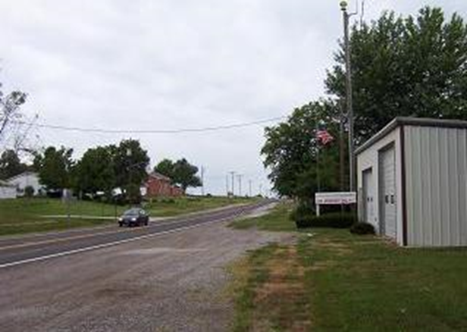

Thanks to Stacey Hamblem and Johnny Joe Tulipana Jr of Dover, Lafayette County, Missouri

By kind permission of the Dover Mercury, (KMG), 11th October 2007

