Dover, Massachusetts, New England, USA
Dover around the World by Lorraine Sencicle

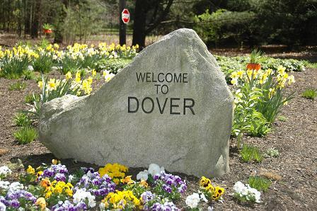
Stone marking the entrance into Dover Massachusetts
Dover, Massachusetts, New England, is possibly the wealthiest of all the 88 Dover's I have researched so far. Coloniser John Smith coined the name, ‘New England’ in 1614, when praising its potential as a settlement. The Pilgrim Fathers arrived four years later; theirs was the first permanent settlement in the State. In 1788, Massachusetts became the sixth of the original 13 States of the US.
Dover, Massachusetts, is a rural, suburban town in the southwestern corner of the Boston metropolitan area some 13 miles from the centre of Boston. The town was part of the Dedham Grant of 1635. This was a huge grant of land by the Massachusetts Bay Colony to settlers south of Boston and eventually formed Norfolk County.
There is no definitive answer as to why Dover in Massachusetts was so called, in fact the Chair of the Parish Committee responsible for seeking incorporation, back in 1784, proposed Derby! However, for reasons still unclear, the Massachusetts Senate inserted the name Dover into the Bill, and thus Derby became Dover! At that time, the town lacked enough ratepayers to elect a representative, so it was not until 1836 before the town was fully incorporated!

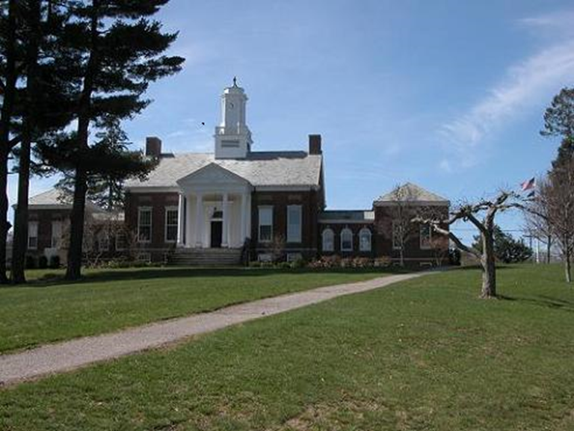
Originally relying on agriculture, throughout the nineteenth century Dover developed into a thriving small town until devastated by fire in 1876. Following this catastrophe the town centre shifted towards the railway, which opened in 1860. By 1900, dairy farming was the main economic force but then two companies set up in the town, Hodgson and Co, the first US manufacturer of prefabricated housing, and the Harvard Apparatus Co, both of which became the main employers for the first half of the twentieth century. At about the same time, wealthy Bostonians discovered that the area as ideal for summer ‘cottages’ - a misnomer as many were very large estates.
By the 1960s Dover had become a thriving suburb based on real estate with 2,846 residents. Now it has 5,923 citizens (2020 census), mainly academic, legal, business and medical most of whom commute to Boston. In 1964, the Massachusetts church enjoyed a reciprocal arrangement with a Dover Church (UK) with Rev Walter Kraft coming here and Rev Percival Humans going to Massachusetts.
In 1977 there were reported sightings of a phenomenon, now known as the Dover Demon - a thing disproportionately large, watermelon-shaped head and bright orange eyes, long thin arms and legs with slender fingers. There were a number of reported sightings, then nothing. In 2004 in Chile, a civil engineer took some photographs of two mounted police and in the developed prints was ... a Dover Demon!
The township does not have a mayor instead it is administered by selectmen - similar to our local councillors but with specific responsibilities and more accountable to the electorate. The town has a full-time police department, one family grocery store, two banks, a post office and four churches. Volunteers man the fire department and it boasts of just one set of traffic lights! The town is fighting hard to maintain its rural charm against the fast-encroaching Boston suburbs.
Thanks: Dr Paul H Tedesco, President, and for the photos, David W Stapleton Jr., Vice President, Dover Historical Society.
Website
By kind permission of the Dover Mercury, (KMG) 7th December 2006

