Dover Mills, Washtenaw County, Michigan, USA
Dover around the World by Lorraine Sencicle

Adjacent to Lenawee County, in southwestern Michigan, is Washtenaw County. Legend has it that the County was named after an American Indian who lived near the mouth of the Huron river. Some believe that Washtenaw means large stream or river, in reference to the Huron while others that it means ‘Far Country,’ in reference to its proximity to Detroit, about 30 miles away.

Within the County are five cites and three incorporated villages, one of the latter is Dexter on the Huron River. When the settlement was founded in 1825, there were several Native American villages in the area. Judge Samuel W Dexter purchased land on which, like other settlers, he grew apples, wheat, corn, barley, oats and clover. He also gave his name to the township of Dexter.

In 1832, along with Judge Dexter another settler, Isaac Pomeroy, built a sawmill. This was taken over but demolished by Daniel B Sloan and Company in 1846, who then built a gristmill. Around the mill a hamlet, called Base Lake, quickly grew and on 30th August 1849, a post office opened with Moses Y Hood, as its first postmaster.

In 1861, Captain Sloan died and Thomas Birkett, who probably had connections with Dover, England, bought the mills. He rebuilt them, renamed the post office Dover Mills and built a church. He also purchased the area around the mills, amounting to some 425acres on which he built a beautiful mansion.
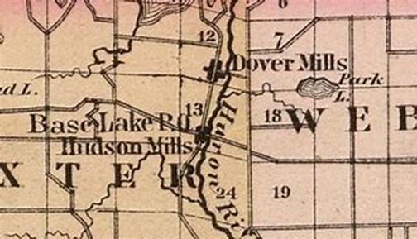

The Old Mill Villages of Dover and Hudson Mills, Washtenaw County

In 1891, Thomas had a Pratt through-truss-bridge built to across the river on which his mills stood. The bridge is unique in that it was easily assembled using iron connecting pins, which made the bridge capable of flexing to accommodate varying weights. Although the post office closed on 14th October 1893 when Thomas died, the bridge remained and was listed on the US National Register of Historic Places. However, a vehicle damaged the structure some years ago, so the bridge was moved to the side of the road and is now just rusting away.

On his death, the Dover Mills, mansion and other mills that Thomas owned, were left to his daughter, Mrs Wirt Newkirt. However, before Thomas's death, his grandson, Birkett Newkirk, suggested that some of the land at Dover Mills should be left to the Y.M.C.A. This he did but sometime later, the land, called Peach Mountain, passed into the hands of the University of Michigan.

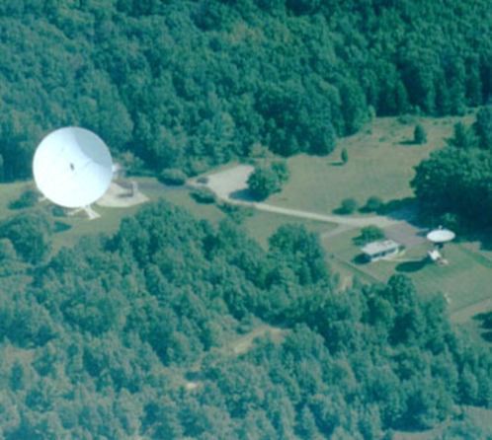
The University quickly realised that as Peach Mountain was not troubled with light pollution it would be ideal for use by the University’s Astronomy Department. In 1955, the Department built an 8.54-metre radio dish; this was later replaced by a 26-metre radio dish. A 24-inch telescope was, in 1958, erected nearby with a unique style of observatory. Instead of having a typical dome, the roof of the building can be moved. This means that when it is the closed position, the telescope can be protected from the elements.

Peach Mountain, part of Stinchfield Woods, is the home of the 24-inch McMath Telescope

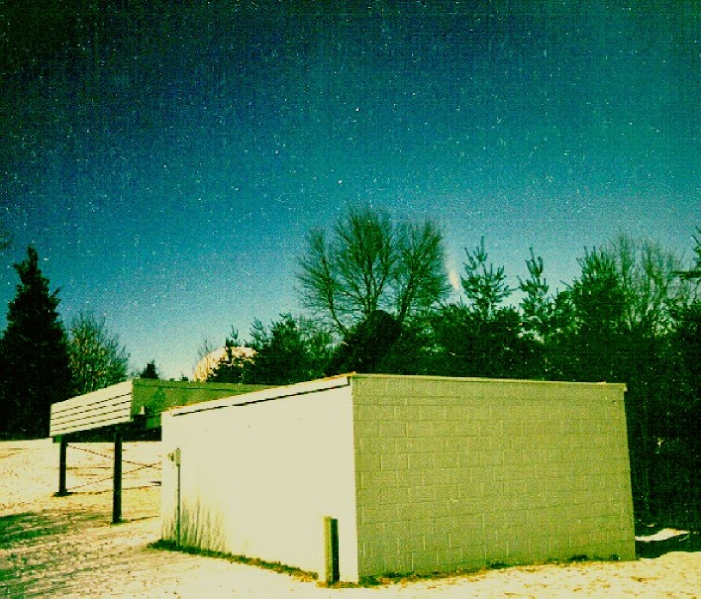
Observatory photo: The 85ft Radio Telescope with the roof open. The Comet Hale-Bopp is visible between the trees. The white disk in the distance behind the observatory building is the University of Michigan Radio Telescope. Photo by Doug Warshaw, 01.04.1997, Kodak Royal Gold 1000 Print film, 50mm lens at f1.8 for 20 secs.

However, in the late 1970s, the University no longer had the need for the observatory, but the Department of Astronomy agreed to give access to a
newly formed amateur astronomers’ society, known as the University of Lowbrow

Astronomers. They refurbished the site and added several pieces of equipment including a computer-controlled system in 1977 and a 6-inch refractor, which is permanently mounted on the side of the telescope. Today, although the Department still owns the land, operational maintenance of the telescope remains the responsibility of the Lowbrows and the site is particularly noted for viewing the Milky Way and the Andromeda galaxy.
Thanks to: Harley B Rider and Paul McCann of Dexter Township, Jennifer Hollenbeck of Metroparks and Dave Snyder and Doug Warshaw, University of Lowbrow Astronomers.

By kind permission of the Dover Mercury, (KMG) August 2008
Links to:
Peach Mountains
Dexter Township
Dover Mills Washtensaw County Michigan Metroparks

