Dover Township, Otsego County, Michigan, USA
Dover around the World by Lorraine Sencicle

Earlier this year the Dovers in Lenawee and Washtenaw counties, Michigan, were described in these pages. This article goes to the northeast of the Lower Michigan Peninsula, and the Great Central Plateau where Dover, Otsego County is located.

Otsego County covers the highest lands of the plateau and was first named by Harry Schoolcraft in 1840 as ‘Okkudo’, a Native American word for ‘sickly’ or ‘stomach pain’. This was changed by Act of Legislature in March 1843 to Otsego, which is believed to mean ‘clear water’. However, due to inaccessibility the land remained a vast, unpopulated, wilderness until 1868 when the first railway reached the county.

Shortly afterwards the first settlers started to arrive making a living from the abundant lumber. With the setters came church ministers, one of whom was Phillip Sparr, who arrived in 1873. At that time Ostego was attached, for administrative purposes, to the adjacent Antrim County, but on 12th March 1875 it became a county in its own right. Townships were established and in 1879 Dover township was formed, within which Phillip Sparr had his base.

In 1902 the House family arrived from Canada and opened at blacksmiths, but the Dover township remained sparsely populated until 1905. That year saw the Boyne City Railroad extend its line from Boyne Falls eastward to the Michigan Central trunk line, through the township to Gaylord five miles away. Salling Hansen Lumber Co had a sawmill near the railway line and the Railway Company opened a switchyard for loading ‘chemical wood’ nearby. Chemical wood was processed into alcohol, turpentine and other wood products at a factory in Gaylord.

The demand for lumber attracted lumbermen to Dover, who set up homes in tarpaper shacks along the railway line. Most of those with young families lived near the sawmill at a place known as Camp 59. They gave Camp 59 a sense of community and was given the name of Sparr after Phillip Sparr. Soon the ubiquitous post office opened that put Sparr on the map. The village quickly grew having its own meat market, dance hall and a school - which doubled as the church on Sundays.

Clearings, made by the lumbermen, were used to grow potatoes and the town of Sparr and the surrounding area of Dover Township prospered. In the 1930s the community boasted of four potato storage houses and produced on average 156 train loads of potatoes a year. Then, in 1935, the railway line closed and not long after the demand for Michigan potatoes also fell. Sparr went into decline.

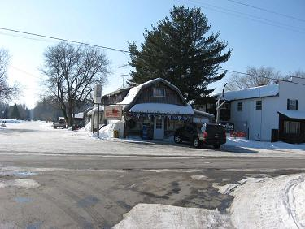
The 2021 census showed the Dover township had a population of 617 people. 530 over the age of 16. The employment rate is 65.70% with 214 in white collar and service jobs and 142 in other employment. The only shop is Sparr Mall, which opened in 1925 by Ira House, the son of the blacksmith. The Mall is particularly noted for the variety of merchandise it has - from bread and doughnuts to hunting knives and jackets, motor-oil to canned food and coffee. This not only serves the nearby farming community but also a thriving tourist trade. For in the winter the township has an average snowfall of 153 inches and is part of the Treetops Sylvan resort, with cross-country ski and snowmobiles routes. In the summer, there is boating, fishing and hunting in the surrounding forests.

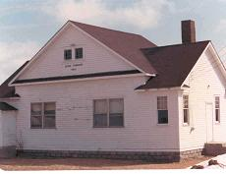
Dover Township Hall

Thanks to: Jackie Skinner and Chris Knight, Library, Gaylord, Otsego, Michigan

