Dover, Olmsted County, Minnesota, USA
Dover around the World by Lorraine Sencicle

When the French arrived in the 17th century, forested Minnesota was inhabited by the Sioux nation. The Sioux were driven out by the Agonquian nation in the 18th century and European settlers followed them. The Mississippi divides this heavily wooded State and lands east of the
river became part of the US Northwest Territories in 1787. The area to the west was part of the Louisiana Purchase of 1803.

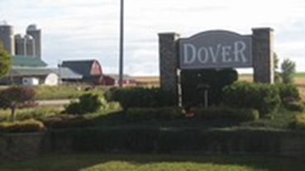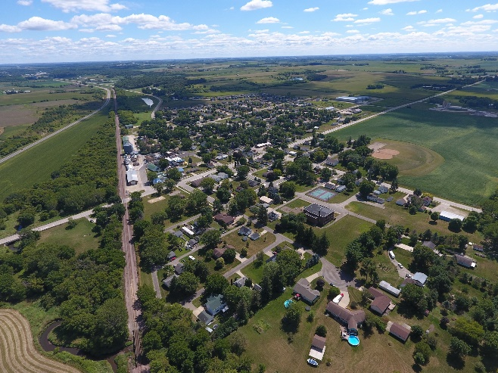
Dover, Olmsted County, Minnesota

The history of Dover, Minnesota began in May 1854 during the great surge of migration west seeking rich farm and timberlands. As pioneers, most of the original settlers were young, strong, daring and determined. Some came from Dover; New Hampshire and it was they who gave the settlement its name. Originally called Dover Center, the postal service often mixed it up with Dodge Centre, a city in a neighbouring county, so Center was dropped when the city was incorporated in December 1908.

Dover is located in Olmsted County in the south-east corner of Minnesota and nestles in a beautiful, peaceful valley, close to three main highways and the Chicago and North-western Railroad. The railway played an important part in the creation of the city as water, required by steam powered locomotives, meant that the railway stations had to be placed six miles apart. Dover was one such stop. The township has a population of 798 people (2020 census) and boasts of a community atmosphere, which is friendly and progressive. Indeed, the people who move there tend to stay. During the summer in nearby parks, there are activities such as swimming, camping and hiking while in the winter, there is cross country skiing and snow shoeing. Annual events include egg hunt for children at Easter and carol singing around a giant tree in the Village Square at Christmas time. Only half an hour away is the Mississippi River.

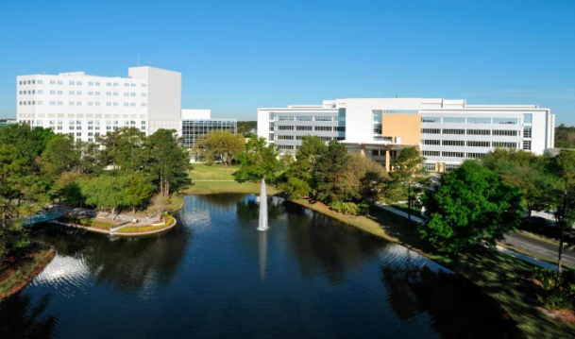
Most of the people who live in Dover work in Rochester, about 16 miles way either at International Business Machines (IBM) or the World-renowned Mayo Clinic. The latter began life as a clinic in Rochester by William Worrall Mayo (1819-1911) and his sons William James Mayo (1861-1939) and Charles Horace Mayo (1865-1939). William snr. moved from England to the United States in 1845, and gained a reputation as a pioneer doctor specialising in gynaecological surgery at a time when surgery and hospitals were hardly thought of. In 1889 he became the senior surgeon at the tiny St. Mary's Hospital in Rochester where his two sons, who had also become physicians, joined him.
Mayo Clinic
William jnr. and Charles travelled widely to learn new surgical techniques, treating appendicitis, gallstones, stomach ulcers, and other often fatal ailments and became famous for their extraordinary surgical skills. In 1915, they opened their clinic which soon became the model for many private clinics throughout the US The clinic is significant not only for its care, in 2004 over 130,000 admissions, but for the way the doctors are paid. In the US doctors are usually paid on the number of patients they see, the more they see, the more they earn. At the Mayo doctors are paid a salary, which means that they can give time to their patients.

At the moment Dover is looking to expand with new homes being constructed. Like us, their water comes from artesian wells, but they also have water towers. Moreover, alongside their new developments they are creating a new lake for stormwater as well as pleasure activities.

Website: Dover Minnesota (dovermn.org)
Facebook: Dover, Minnesota | Dover MN | Facebook

By kind permission of the Dover Mercury, (KMG), 7th June 2007

